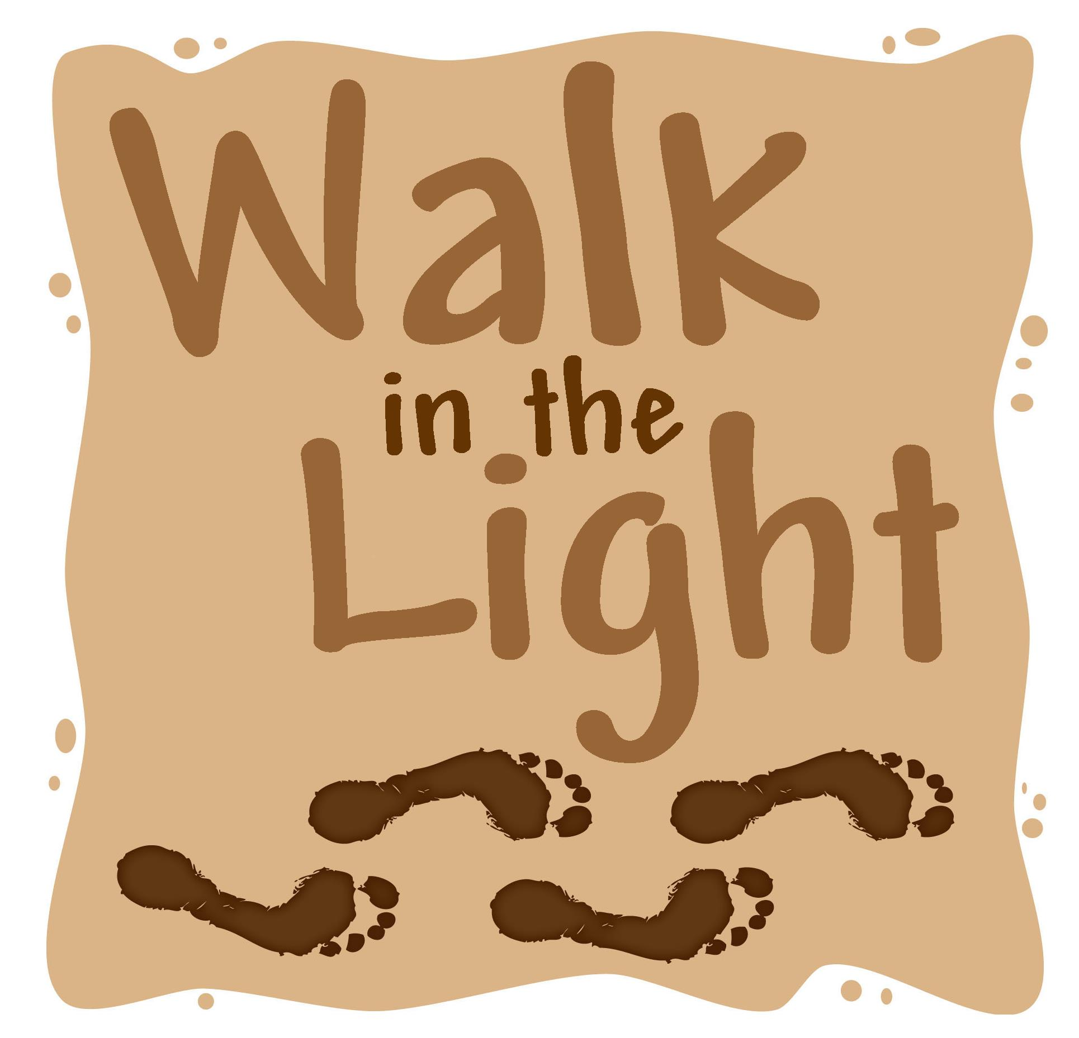
Church School Registration

Registration for:
Sunday or Wednesday
(circle one)

Parents’ Name(s)

Phone: Alt. Phone:

Address:

Zip

Student Enrolling:

Name: Grade: Birth date:

Church school fees are $20.00 per student for the year.

$40 maximum per family. Scholarships are available.

University Lutheran Church
2122 University Ave.

Grand Forks, ND 58203
(701) 775-4745
Universitylutherangf.com
www.facebook.com/universitylutheranchurch
Confirmation Registration

Registration for:
Sunday or Wednesday
(circle one)

Parents’ Name(s)

Phone: Alt. Phone:

Address:

Zip

Student Enrolling:

Name: Grade: Birth date:

Confirmation fees are $20.00 per student for the year. Scholarships are available.
University Lutheran Church
2122 University Ave.

Grand Forks, ND 58203
(701) 775-4745
Universitylutherangf.com
www.facebook.com/universitylutheranchurch

